**ABSTRACT**

Initially the GPS continuously takes input data from the satellite and stores the latitude and longitude values in AT89s52 microcontroller's buffer. If we have to track the vehicle, we need to send a message to GSM device, by which it gets activated. It also gets activated by detecting accident on the IR sensor, by detecting fire on the temperature sensor, by detecting theft connected to vehicle. Parallels deactivates GPS with the help of relay. Once GSM gets activated it takes the last received latitude and longitude positions values from the buffer and sends a message to the particular number or laptop which is predefined in the program. Once message has been sent to the predefined device the GSM gets deactivated and GPS gets activated. The Objective of this project is to avoid vehicle theft and control & to avoid the collision between two vehicles and to take some safety measurements and this project is to design an efficient driving guidance system based on sensor networks. The purpose of this project is to design and develop a Vehicle Accident Report System in highways. The vehicle accident is detected using a MEMS sensor and reported using a GSM Module and this project focuses on developing an embedded system to report information regarding road vehicles accidents on highways automatically using MEMS and GSM modem.

**Key Words**: Vehicle tracking security, GPS, GSM, SMS, Arduino microcontroller. Mobile application, RFID READER

**INTRODUCTION:**

The Objective of this project is to avoid vehicle theft and control & to avoid the collision between two vehicles and to take some safety measurements and this project is to design an efficient driving guidance system based on sensor networks. The purpose of this project is to design and develop a Vehicle Accident Report System in highways. The vehicle accident is detected using a MEMS sensor and reported using a GSM Module and this project focuses on developing an embedded system to report information regarding road vehicles accidents on highways automatically using MEMS and GSM modem. Vehicle tracking system main aim is to give Security to all vehicles. Accident alert system main aim is to rescuing people in accidents. This is improved security systems for vehicles. The latest like GPS are highly useful now a day, this system enables the owner to observe and track his vehicle and find out vehicle movement and its past activities of vehicle.

This new technology, popularly called vehicle Tracking Systems which created many wonders in the security of the vehicle. This hardware is fitted on to the vehicle in such a manner that it is not visible to anyone who is inside or outside of the vehicle. Thus it is used as a covert unit which continuously or by any interrupt to the system, sends the location data to the monitoring unit. When the vehicle is stolen, the location data from tracking system can be used to find the location and can be informed to police for further action. Some Vehicle tracking System can even detect unauthorized movements of the vehicle and then alert the owner. This gives an edge over other pieces of technology for the same purpose.

This accident alert system in it detects the accident and the location of the accident occurred and sends GPS coordinates to the specified mobile, computer etc. The fire detector circuit in it is used to detect fire in the vehicle, if the temperature inside the vehicle goes above a certain limit then a warning will be automatically send to the intend receiver. The infrared sensor which is additionally interfaced to the microcontroller is used to detect the obstacles and accidents, in any case if any mishap occurs then its warning will be directly send to the intended receiver.

When a request by user is sent to the number at the modem, the system automatically sends a return reply to that particular mobile indicating the position of the vehicle in terms of latitude

and longitude. A Program has been developed which is used to locate the exact position of the vehicle and also to navigated track of the moving vehicle on Google Map.

**LITERATURE REVIEW**

According to Prof. BaburaoKodavati (Asst. Prof in ECE Dept.), in his paper titled ‘GSM AND GPS BASED VEHICLE LOCATION AND TRACKING SYSTEM’ has concluded by saying that vehicle tracking system is necessary to prevent any vehicle theft and also allows to remotely control a vehicle only by a text message.

According to Mr. NileshManganakar (BE-IT), in his paper titled ‘REAL TIME TRACKING OF COMPLETE TRANSPORT SYSTEM USING GPS’ has concluded by saying that GPS tracking system is useful for a user to track the current position of vehicle thus reducing waiting time for travelling.

According to Mr. PankajVerma, in his paper titled ‘DESIGN AND DEVELOPMENT OF GPS-GSM BASED TRACKING SYSTEM WITH GOOGLE MAP BASED MONITORING’ has concluded by saying that it is useful for making vehicles more secure by use of GPS and GSM technologies and can also be useful for tracking animals in jungles, various department services such as fire etc.

According to Mr. KunalMaurya, in his paper titled ‘REAL TIME VEHICLE TRACKING SYSTEM USING GSM AND GPS TECHNOLOGY- AN ANTI-THEFT TRACKING SYSTEM’ has concluded by stating that besides being useful in animal tracking and asset tracking, the proposed system in future can be assimilated with other related devices such as sensors thus resulting in a smart tracking system.

**DESCRIPTION**

**Security Part:**

The vehicle door is opened by using RFID Reader, if the RFID tag no. matches, the vehicle door is opened, otherwise the door will not be opened, if the door is forcibly opened and try to operate the vehicle by using the key, the location of the vehicle will be sent to the owner of the vehicle along with which the engine will be locked.

**Accident Avoidance part:**

Although the task of developing vehicle systems capable of driving themselves in current highway and urban contexts is exceedingly complex, scientists and engineers are pushing the envelope to bring the idea of truly smart cars into mainstream reality. For a vehicle to be able to drive by itself, it needs its own senses, brain, control and guidance to perceive and react to its environment.

Pre-collision systems are active safety systems designed for automobiles to avoid or minimize the extent of damage in the event of a crash. These systems evaluate the position of the driver and his environment constantly to predict a likely accident and take steps in advance to minimize injury. They may either brief up the active safety systems in the car or even brake automatically to bring the car to a halt.

Early pre-collision systems used infrared rays to detect the traffic movement. Infrared had limited visibility, which reduced the effectiveness of such systems. Modern systems are radar based, using ultrasound, radio waves or laser and moisture sensor, temperature sensor, eye blink sensor etc.. so as to monitor the car’s environment constantly. These systems can detect the position, distance and relative velocity of more than one vehicle in front of the car at any time.

Some systems produce an alarm to alert the driver if the radar finds out a potentially hazardous circumstance. Others take over the control of some aspects of the car like braking. They prepare the car for a collision by tightening the seat belts and arranging the seats of the car so that the passengers are aligned to be perfectly protected by the airbags. Some of these systems pre-charge the cars brake so as to improve the response time or even provide additional-braking pressure to bring the car to a halt. Advanced system will automatically brake the car, bringing it to a pause before crashing on to another car.

**Accident reporting part:**

This setup is fixed on the road vehicles and during normal movement (X-axis), the accelerometer output is nearly constant. When any accident occurs the MEMS sensor gives unbalanced or high axis output value (depends on vehicle position), and then the microcontroller reads the value and expects for the normal movement output value again on same axis (X-axis).

If the output is not returning back to normal value within the specific time then the microcontroller commands the GSM modem and send a SMS to any predefined numbers such as ambulance or police or any other numbers to intimate the accident.

**BLOCK DIAGRAM:**

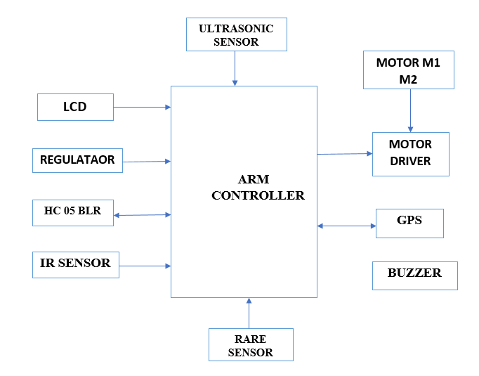

**RECEIVER:**

8051

Controler

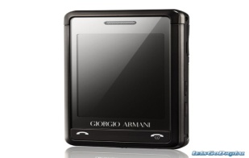

The Receiver block consists of mobile using GSM capable of receiving message signal transmitted by the transmitting block which consists of GPS data (google map) giving the exact location of the vehicle to the owner.

**HARDWARE REQUIREMENTS:**

1. Microcontroller with Display Device
2. GPS module and GSM Modem
3. RFID Reader
4. IR module
5. LDR
6. Temperature Sensor
7. Ultrasonic Sensor
8. Accelerometer/ Gyro/ MEMS Sensor
9. LED & Buzzer
10. Geared DC motors and Motor driver
11. Regulated power supply module.
12. 12V battery.

**INTRODUCTION ABOUT ARDUINO UNO**

Arduino is an open-source prototyping platform based on easy-to-use hardware and software. Arduino boards are able to read inputs - light on a sensor, a finger on a button, or a Twitter message - and turn it into an output - activating a motor, turning on an LED, publishing something online. You can tell your board what to do by sending a set of instructions to the microcontroller on the board. To do so you use the Arduino programming language (based on Wiring), and the Arduino Software (IDE), based on Processing.

Over the years Arduino has been the brain of thousands of projects, from everyday objects to complex scientific instruments. A worldwide community of makers - students, hobbyists, artists, programmers, and professionals - has gathered around this open-source platform, their contributions have added up to an incredible amount of accessible knowledge that can be of great help to novices and experts alike.

Arduino was born at the Ivrea Interaction Design Institute as an easy tool for fast prototyping, aimed at students without a background in electronics and programming. As soon as it reached a wider community, the Arduino board started changing to adapt to new needs and challenges, differentiating its offer from simple 8-bit boards to products for IoT applications, wearable, 3D printing, and embedded environments. All Arduino boards are completely open-source, empowering users to build them independently and eventually adapt them to their particular needs. The software, too, is open-source, and it is growing through the contributions of users worldwide.

**WHY ARDUINO?**

Thanks to its simple and accessible user experience, Arduino has been used in thousands of different projects and applications. The Arduino software is easy-to-use for beginners, yet flexible enough for advanced users. It runs on Mac, Windows, and Linux. Teachers and students use it to build low cost scientific instruments, to prove chemistry and physics principles, or to get started with programming and robotics. Designers and architects build interactive prototypes, musicians and artists use it for installations and to experiment with new musical instruments. Makers, of course, use it to build many of the projects exhibited at the Maker Faire, for example. Arduino is a key tool to learn new things. Anyone - children,

hobbyists, artists, programmers - can start tinkering just following the step by step instructions of a kit, or sharing ideas online with other members of the Arduino community.

There are many other microcontrollers and microcontroller platforms available for physical computing. Parallax Basic Stamp, Net media’s BX-24, Phi gets, MIT's Handy board, and many others offer similar functionality. All of these tools take the messy details of microcontroller programming and wrap it up in an easy-to-use package. Arduino also simplifies the process of working with microcontrollers, but it offers some advantage for teachers, students, and interested amateurs over other systems:

**INEXPENSIVE** - Arduino boards are relatively inexpensive compared to other microcontroller platforms. The least expensive version of the Arduino module can be assembled by hand, and even the pre-assembled Arduino modules cost less than $50

**CROSS-PLATFORM** - The Arduino Software (IDE) runs on Windows, Macintosh OSX, and Linux operating systems. Most microcontroller systems are limited to Windows.

**SIMPLE, CLEAR PROGRAMMING ENVIRONMENT** - The Arduino Software (IDE) is easy-to-use for beginners, yet flexible enough for advanced users to take advantage of as well. For teachers, it's conveniently based on the Processing programming environment, so students learning to program in that environment will be familiar with how the Arduino IDE works.

**OPEN SOURCE AND EXTENSIBLE SOFTWARE** - The Arduino software is published as open source tools, available for extension by experienced programmers. The language can be expanded through C++ libraries, and people wanting to understand the technical details can make the leap from Arduino to the AVR C programming language on which it's based. Similarly, you can add AVR-C code directly into your Arduino programs if you want to.

**OPEN SOURCE AND EXTENSIBLE HARDWARE** - The plans of the Arduino boards are published under a Creative Commons license, so experienced circuit designers can make their own version of the module, extending it and improving it. Even relatively inexperienced users can build the breadboard version of the module in order to understand how it works and save money.

**ARDUINO – SOFTWARE:**

The Arduino software consists of two parts as shown

[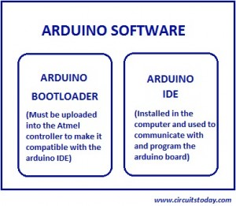](http://www.circuitstoday.com/wp-content/uploads/2012/02/Arduinosoft.jpg)

**BOOTLOADER**  
Boot loader is a little piece of code residing inside the microcontroller which makes the controller special and gives it the power of integration to the Arduino IDE and the arduino board. With the boot loader erased, when you try to program from the IDE, the controller won’t understand anything! In simple words, the boot loader acts as a translator between the controller and the arduino IDE. You have to load the boot loader in to the controller (from a different programmer) before integrating it with the arduino board.

**IDE(INTEGRATED-DEVELOPMENT-ENVIRONMENT**  
The Arduino IDE is installed in the computer. The IDE has a compiler, serial monitor etc. Arduino language is a variant of c++ – at least it looks like c++ programs. Program is written, compiled and uploaded from the IDE to the board. The language is really really simple! The IDE has the options to select from different versions of Arduino board with different controllers and also has options to select the particular communication port where the Arduino board is connected.

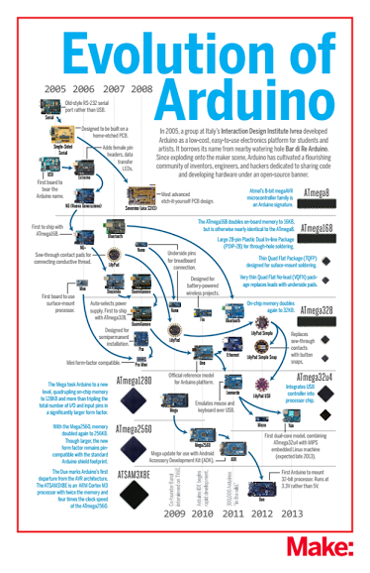**Arduino Family**

**ARDUINO UNO**

"Uno" means one in Italian and is named to mark the upcoming release of Arduino 1.0. The Uno and version 1.0 will be the reference versions of Arduino, moving forward. The Uno is the latest in a series of USB Arduino boards, and the reference model for the Arduino platform;

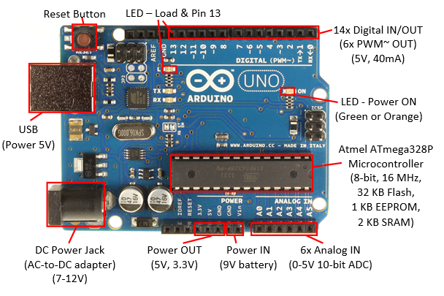

**TECHNICAL SPECIFICATION**

|  |  |
| --- | --- |
| Microcontroller | [ATmega328P](http://www.atmel.com/Images/doc8161.pdf) |
| Operating Voltage | 5V |
| Input Voltage (recommended) | 7-12V |
| Input Voltage (limit) | 6-20V |
| Digital I/O Pins | 14 (of which 6 provide PWM output) |
| PWM Digital I/O Pins | 6 |
| Analog Input Pins | 6 |
| DC Current per I/O Pin | 20 mA |
| DC Current for 3.3V Pin | 50 mA |
| Flash Memory | 32 KB (ATmega328P) of which 0.5 KB used by boot loader |
| SRAM | 2 KB (ATmega328P) |
| EEPROM | 1 KB (ATmega328P) |
| Clock Speed | 16 MHz |
| Length | 68.6 mm |
| Width | 53.4 mm |
| Weight | 25 g |

**PIN MAPPING**

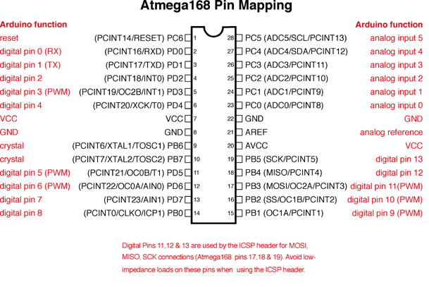

• **Serial: 0 (RX) and 1 (TX).** Used to receive (RX) and transmit (TX) TTL serial data. TThese pins are connected to the corresponding pins of the ATmega8U2 USB-to-TTL Serial chip.

• **External Interrupts**: 2 and 3. These pins can be configured to trigger an interrupt on a low value, a rising or falling edge, or a change in value. See the attach Interrupt () function for details.

• **PWM: 3, 5, 6, 9, 10, and 11**. Provide 8-bit PWM output with the analog Write () function.

• **SPI: 10 (SS), 11 (MOSI), 12 (MISO), 13 (SCK).** These pins support SPI communication, which, although provided by the underlying hardware, is not currently included in the Arduino language.

• **LED: 13**. There is a built-in LED connected to digital pin 13. When the pin is HIGH value, the LED is on, when the pin is LOW, it's off.

The Uno has 6 analog inputs, each of which provide 10 bits of resolution (i.e. 1024 different values). By default, they measure from ground to 5 volts, though is it possible to change the

upper end of their range using the AREF pin and the analog Reference () function. Additionally, some pins have specialized functionality:

• **I 2C: 4 (SDA) and 5 (SCL**). Support I2C (TWI) communication using the Wire library. There are a couple of other pins on the board:

• **AREF**. Reference voltage for the analog inputs. Used with analog Reference ().

• **Reset.** Bring this line LOW to reset the microcontroller. Typically used to add a reset button to shields which block the one on the board.

**COMMUNICATION**

The Arduino Uno has a number of facilities for communicating with a computer, another Arduino, or other microcontrollers. The ATmega328 provides UART TTL (5V) serial communication, which is available on digital pins 0 (RX) and 1 (TX). An ATmega8U2 on the board channels this serial communication over USB and appears as a virtual com port to software on the computer. The '8U2 firmware uses the standard USB COM drivers, and no external driver is needed. However, on Windows, an *.inf file is required. The Arduino software includes a serial monitor which allows simple textual data to be sent to and from the Arduino board. The RX and TX LEDs on the board will flash when data is being transmitted via the USB-to serial chip and USB connection to the computer (but not for serial communication on pins 0 and 1). A Software Serial library allows for serial communication on any of the Uno's digital pins. The ATmega328 also support I2C (TWI) and SPI communication. The Arduino software includes a Wire library to simplify use of the I2C bus; see the documentation for details. To use the SPI communication, please see the ATmega328 datasheet.

**PROGRAMMING**

## LANGUAGE REFERENCE

Arduino programs can be divided in three main parts: structure, values (variables and constants), and functions.

* **STRUCTURE**
* setup()
* loop()

## setup()

The setup() function is called when a sketch starts. Use it to initialize variables, pin modes, start using libraries, etc. The setup function will only run once, after each power up or reset of the Arduino board.

loop()

After creating a setup() function, which initializes and sets the initial values, the loop() function does precisely what its name suggests, and loops consecutively, allowing your program to change and respond. Use it to actively control the Arduino board.

Ex:

const int buttonPin = 3;

// setup initializes serial and the button pin

void setup()

{

Serial.begin(9600);

pinMode(buttonPin, INPUT);

}

// loop checks the button pin each time,

// and will send serial if it is pressed

void loop ()

{

if (digital Read(buttonPin) == HIGH)

Serial. Write('H');

else

Serial.write('L');

delay(1000);

}

**Relay Module**

This is a LOW Level 5V 2-channel relay interface board, and each channel needs a 15-20mA driver current. It can be used to control various appliances and equipment with large current. It is equipped with high-current relays that work under AC250V 10A or DC30V 10A. It has a standard interface that can be controlled directly by microcontroller. This module is optically isolated from high voltage side for safety requirement and also prevent ground loop when interface to microcontroller.

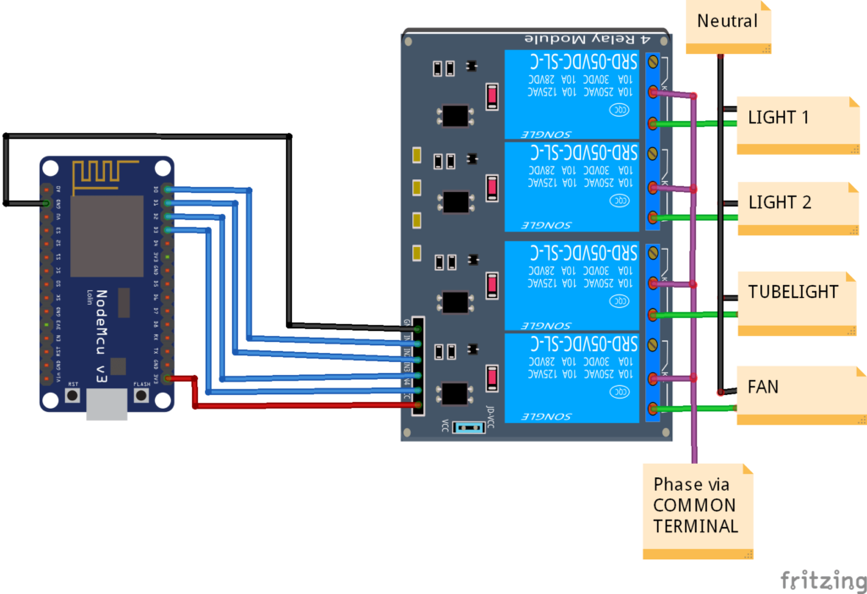

**Specifications**

• Relay Maximum output: DC 30V/10A, AC 250V/10A.

• 2 Channel Relay Module with Opto-coupler. LOW Level Trigger expansion board, which is compatible with Arduino control board.

• Standard interface that can be controlled directly by microcontroller (8051, AVR, *PIC, DSP, ARM, ARM, MSP430, TTL logic).

• Relay of high quality low noise relays SPDT. A common terminal, a normally open, one normally closed terminal.

• Opto-Coupler isolation, for high voltage safety and prevent ground loop with microcontroller.

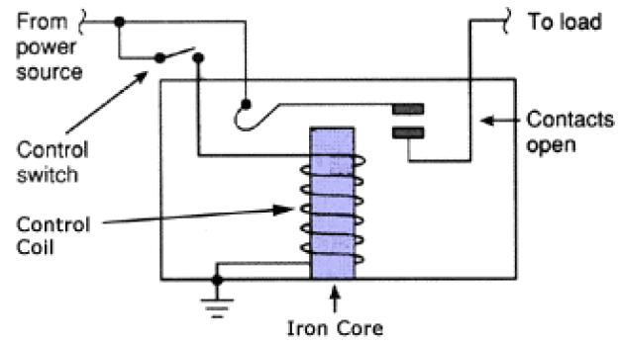

**Output**:

Each module of the relay has one NC (normally close), one NO (normally open) and one COM (Common) terminal. So there are 2 NC, 2 NO and 2 COM of the channel relay in total. NC stands for the normal close port contact and the state without power. NO stands for the normal open port contact and the state with power. COM means the common port. You can choose NC port or NO port according to whether power or not.

**Testing Setup**:

When a low level is supplied to signal terminal of the 2-channel relay, the LED at the output terminal will light up. Otherwise, it will turn off. If a periodic high and low level is supplied to the signal terminal, you can see the LED will cycle between on and off.

**POWER REGULATOR**

To decrease power consumption and increase the speed, the next generation of computer microprocessors will operate at significantly lower voltages and higher currents than today's generation. At the same time, these microprocessors will require a highly accurate supply voltage regulation which cannot be achieved by a centralized power system. A specified regulation accuracy can be accomplished with the distributed power system where a high-quality power is delivered to the microprocessor by a voltage regulator module (VRM), which is located on the motherboard next to the load. Generally, the VRM is required to have a high power density and to operate with a high efficiency. To meet these requirements and to provide a fast transient response, the power conversion must be performed at a high switching frequency, which presents a serious design challenge. This paper deals with the design of a VRM supplying power from a 12-V tightly regulated bus to a 0.9-1.5 V, 50-A load which exhibits current transients with a slew rate of 50A/ µs. For the present VRMs with the load current in the 15-A to 20-A range, the conventional buck topology with synchronous rectifier (SR), shown in Fig. 1, has been proven to represent a good performance/cost trade-off. However, if a single buck converter topology were employed in the 12-V/1.5-V, 50-A VRM, then, to achieve the specified load transient response, a large amount of the output-filter and on-board decoupling capacitance would be required [1]-[4]. The size of the VRM would increase as well as the required space on the motherboard, making the conventional single-module buck converter topology not practical. The amount of required output-filter and decoupling capacitances can be minimized by employing the interleaving technique, as demonstrated in [2]. Generally, the interleaving technique is implemented by paralleling a number of converter modules, and by phase-shifting (interleaving) their drive signals. The main benefit of the interleaving is the increased output ripple frequency which is equal to the product of the single-module switching frequency and the number of the interleaved modules. Specifically, the increased output-ripple frequency makes possible to reduce the output filter capacitance, as well as to increase the control-loop bandwidth to improve the transient response. Additional benefits of interleaving include better thermal management and packaging flexibility.

**HC-05 -BLUETOOTH TO SERIAL PORT MODULE**

HC-05 module is an easy to use Bluetooth SPP (Serial Port Protocol) module, designed for transparent wireless serial connection setup. Serial port Bluetooth module is fully qualified Bluetooth V2.0+EDR (Enhanced Data Rate) 3Mbps Modulation with complete 2.4GHz radio transceiver and baseband. It uses CSR Blue core 04-External single chip Bluetooth system with CMOS technology and with AFH (Adaptive Frequency Hopping Feature). It has the footprint as small as 12.7mmx27mm. Hope it will simplify your overall design/development cycle.

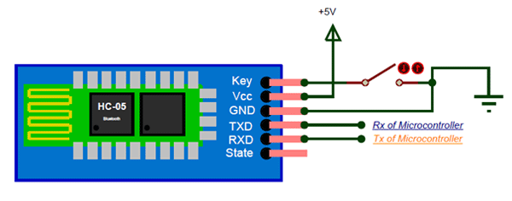

**SPECIFICATIONS**

**HARDWARE FEATURES**

* Typical -80dBm sensitivity]

* Up to +4dBm RF transmit power

* Low Power 1.8V Operation ,1.8 to 3.6V I/O

* PIO control

* UART interface with programmable baud rate

* With integrated antenna

* With edge connector

**SOFTWARE FEATURES**

* Default Baud rate: 38400, Data bits:8, Stop bit:1, Parity: No parity, Data control: has. Supported baud rate: 9600,19200,38400,57600,115200,230400,460800.

* Given a rising pulse in PIO0, device will be disconnected.

* Status instruction port PIO1: low-disconnected, high-connected;

* PIO10 and PIO11 can be connected to red and blue led separately. When master and slave are paired, red and blue led blinks 1time/2s in interval, while disconnected only blue led blinks 2times/s.

* Auto-connect to the last device on power as default. λ Permit pairing device to connect as default.

* Auto-pairing PINCODE:”0000” as default

* Auto-reconnect in 30 min when disconnected as a result of beyond the range of connection.

**MOTOR DRIVER**

Overview: L293D is a typical Motor driver or Motor Driver IC which allows DC motor to drive on either direction. L293D is a 16-pin IC which can control a set of two DC motors simultaneously in any direction. It means that you can control two DC motor with a single L293D IC. Dual H-bridge Motor Driver integrated circuit (IC).

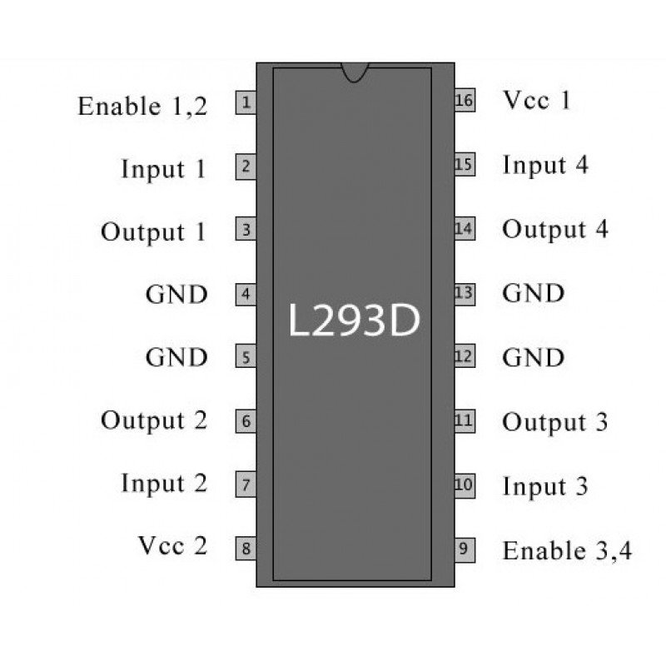

It works on the concept of H-bridge. H-bridge is a circuit which allows the voltage to be flown in either direction. As you know voltage need to change its direction for being able to rotate the motor in clockwise or anticlockwise direction, Hence H-bridge IC are ideal for driving a DC motor. In a single L293D chip there are two h-Bridge circuit inside the IC which can rotate two dc motor independently. Due its size it is very much used in robotic application for controlling DC motors. Given below is the pin diagram of a L293D motor controller. There are two Enable pins on l293d. Pin 1 and pin 9, for being able to drive the motor, the pin 1 and 9 need to be high. For driving the motor with left H-bridge you need to enable pin 1 to high. And for right H-Bridge you need to make the pin 9 to high. If anyone of the either pin1 or pin9 goes low, then the motor in the corresponding section will suspend working. It’s like a switch.

VCC is the voltage that it needs for its own internal operation 5v; L293D will not use this voltage for driving the motor. For driving the motors, it has a separate provision to provide motor supply VSS (V supply). L293d will use this to drive the motor. It means if you want to operate a motor at 9V then you need to provide a Supply of 9V across VSS Motor supply. The maximum voltage for VSS motor supply is 36V. It can supply a max current of 600mA per channel. Since it can drive motors Up to 36v hence you can drive pretty big motors with this l293d. VCC pin 16 is the voltage for its own internal Operation. The maximum voltage ranges from 5v and up to 36v.

Let’s consider a Motor connected on left side output pins (pin 3,6). For rotating the motor in clockwise direction the input pins have to be provided with Logic 1 and Logic 0.

• Pin 2 = Logic 1 and Pin 7 = Logic 0 | Clockwise Direction

• Pin 2 = Logic 0 and Pin 7 = Logic 1 | Anticlockwise Direction

• Pin 2 = Logic 0 and Pin 7 = Logic 0 | Idle [No rotation] [Hi-Impedance state]

• Pin 2 = Logic 1 and Pin 7 = Logic 1 | Idle [No rotation] In a very similar way the motor can also operate across input pin 15,10 for motor on the right hand side.

**KEY FEATURES:**

• Design based on highly proven IC L293D driver

• Direct input from 5V microcontroller for L293D driver supply.

• Output terminal for both motor.

• Powered from external 12V or from wire header Kit Includes

• On Board components only. Accessories:

• Multi meter, connecting wires, DC Motors.

**DC MOTORS**

Motor1 is a 12V DC geared motor with a .25” motor output shaft and a 2mm rear encoder shaft. The 2mm shaft works with our ENC300 quadrature encoder to allow the motor to be used in position control applications. Motor controllers that are rated for 12V@2A are ideal for controlling this motor. However, motor controllers with lower current ratings can also be used if they have over-current and over temperature protection.

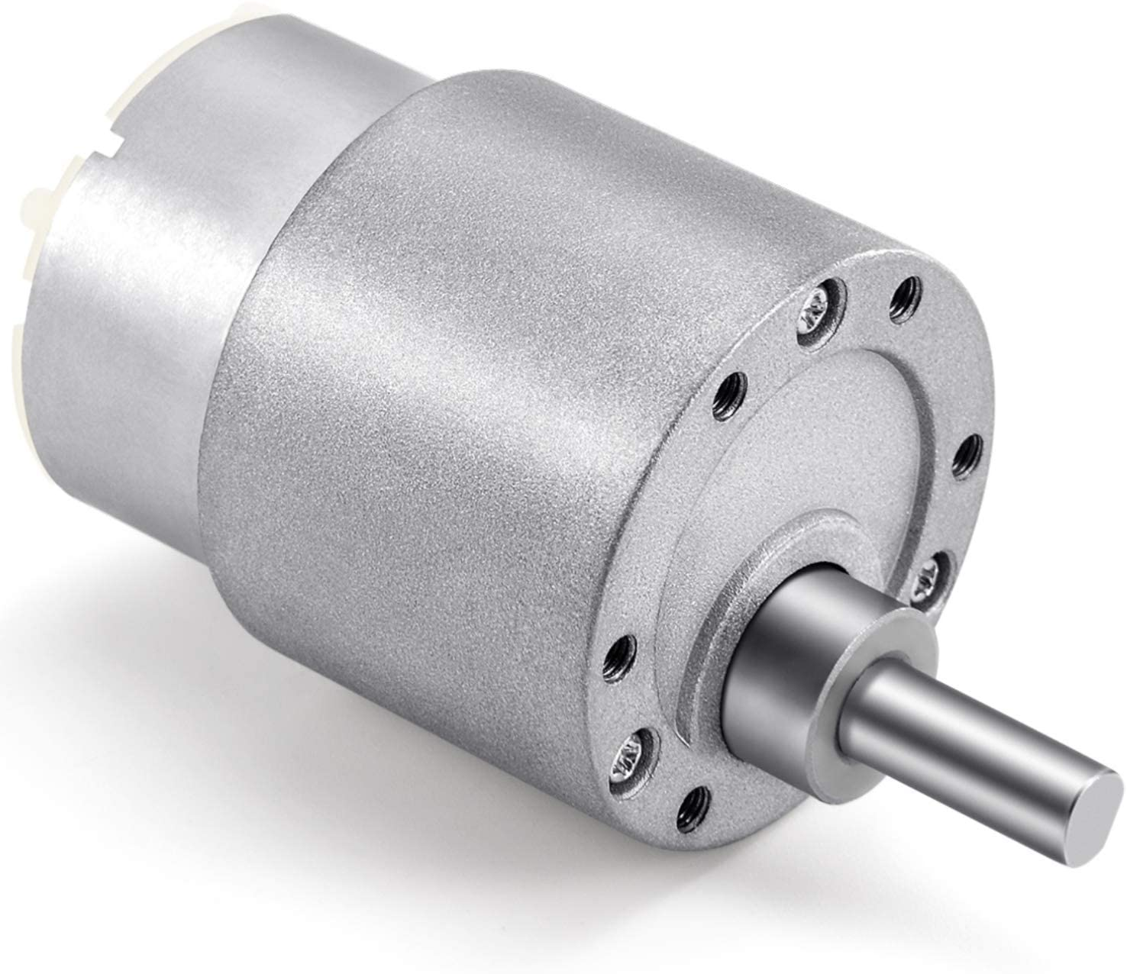

In Industry DC motor is widely uses for speed control and load characteristics, it’s easy controllability provide effective and precise output. So, application of DC motor is large for commercial purpose. Speed control of DC motor is very crucial in application where required speed is precision and correcting signal representing and to operate motor at constant speed, so we used PWM method which are fulfil all requirements to speed control of DC motor.PWM based speed control system consists of electronic components (integrated circuit, Potentiometer etc.). In this Project 555 timer (NE55P) is being operated in actable mode, which produce a continuous HIGH and LOW pulses. The 555 Timer is capable of generating PWM signal when set up in an actable mode. In this mode, the 555 IC can be used as a pulse width modulator with a few small adjustments to the circuit. The frequency of operation of the circuit is provided by the passive parameters of resistances and capacitors attached to it. The speed control of DC motor is important in applications where precision and protection are of essence. The variable speed drives, till a couple of decades back, had various limitations, such as poor efficiencies, larger space, lower speeds, etc., However, the advent power electronic devices such as power MOSFETs, IGBTs etc., and today we have variable speed drive systems which are not only in the smaller in size but also very efficient, highly reliable and meeting all the stringent demands of various industries of modern era. Direct currents (DC) motors have been used in variable speed drives for a long time. The versatile characteristics of dc motors can provide high starting torques which is required for traction drives. Control over a wide speed range, both below and above the rated speed can be very easily achieved. The methods of speed control are simpler and less expensive than those of alternating current motors. There are different techniques available for the speed control of DC motors. The phase control method is widely adopted in which ac to dc converters are used to supply the dc motors, but has certain limitations mainly it generates harmonics on the power line and it also has poor p.f. when operated at lower speeds. The second method is pwm technique, which has got better advantages over the phase control. In order to have better open loop speed control as demand varies frequently like in traction system and many operations in industry must be control manually, PWM is most efficient and Page | iv cheap speed control method for dc drives. By varying resistor pot only, we can control the speed of motor states that simple and easy method.

**GPS LOCATION**

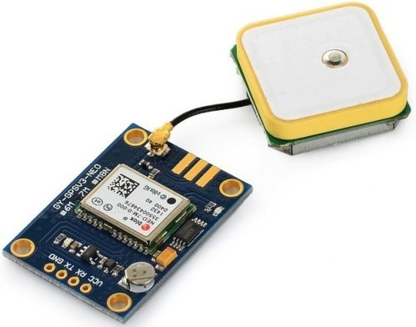

Global System for Mobile Communication (GSM) and Global Positioning System (GPS) based vehicle location and tracking system provided effective, real time vehicle location, mapping and reporting this information value and add by improving this level of service provided. The GPS based vehicle tracking system is designed to find out the exact location of any vehicle and intimate the position to the concerned authority about through an SMS. The system includes a GPS modem that it retrieves the location of a vehicle in terms of its longitude and latitude. The system uses geographic position and time information from the GPS. The system has an onboard module that it resides in the vehicle to be tracked and a based station that monitors data from the various vehicles. The onboard module consists of GPS receiver, a GSM modem. This hardware is fitted on to the vehicle in such a manner that it was not visible to anyone. That system sends the location data to the monitoring unit continuously therefore it is used as a covert unit. The location data from tracking system uses to find the location and to give the information to police when the vehicle is stolen. This gives an edge over other pieces of technology for the same purpose. The system automatically sends a return reply to that particular mobile indicating the position of the vehicle in terms of latitude and longitude when a request by user is sent to the number at the modem. A program has been developed that it is used to locate the exact position of the vehicle and also to navigated track of the moving vehicle on Google map. The system allows to track the target anytime and anywhere in any weather conditions. This system is user friendly, easily installable, easily accessible and can be used for various other purpose.

**SOFTWARE REQUIREMENTS:**

1. Arduino IDE
2. Blink app
3. Embedded C.

**ADVANTAGE:**

1. To locate the position of the vehicle in Defense
2. Can be used in cars, bus, ship safety system
3. Automotive applications and so on
4. For the safety of the driver

**DISADVANTAGES:**

1. In real time it’s hard to stop the vehicle immediately

**CONCLUSION:**

In this paper we have proposed an anti-theft system which can be used to track a vehicle fitted with the proposed device in it. It can also be used in wildlife tracking, asset tracking and in stolen vehicle recovery. In the future we may integrate other related devices in a vehicle such as sensors. We can create a server to see the vehicle route and other information on our computer and we can save the trajectory of it. The sensors installed in our vehicle can report the vehicle information to our server and it can form an intelligent tracking system. There are various reasons why car owners and public vehicle operators prefer to have a GPS. You can determine your location, whether you are travelling locally or in a foreign land, having a GPS is truly an advantage. If you think you are lost, you can use your GPS receiver to know your exact location. Vehicle tracking systems are commonly used by fleet operators for fleet management functions such as routing, dispatch, on-board information and security. Other applications include monitoring driving behaviour, such as an employer of an employee, or a parent with a teen driver. In this paper, GSM module used to send and receive message from another GSM number. If the owner of the vehicle wants to know their vehicle location, they have to send find message firstly. At that time, GSM module was working to send back to the owner mobile phone number. In this thesis, GPS module also contains so that message contains the location of their vehicle latitude and longitude. If the owner wants to see on Google map, it shows the location of their vehicle. Therefore, the user easily knows their vehicle location when the vehicle was stolen. If the nothing message is sending the owner, the operation is performed according to the code so LCD was displaying “HI”. Firstly, this system had to wait a little second to active GSM module and GPS module. After active system, it had to show the result on serial monitor.

**REFERENCE**

[1] K.S. Alli, C. Ijeh-Ogboi and S.L. Gbadamosi “Design and Construction of a remotely controlled vehicle anti-theft system via GSM network” International Journal of Education and Research vol. 3 No. 5 May 2015.

[2] S. Boopathi, K. Govindaraju, M. Sangeetha, M. Jagadeeshraja, M. Dhanasu “Real Time Based Smart Vehicle Monitoring and Alert Using GSM” International Journal of Advanced Research in Computer and Communication Engineering Vol. 3, Issue 11, November 2014, ISSN (Online): 2278-1021, ISSN (Print): 2319- 5940.

[3] Kunal Maurya , Mandeep Singh, Neelu Jain, “Real Time Vehicle Tracking System using GSM and GPS Technology- An Anti-theft Tracking System”, International Journal of Electronics and Computer Science Engineering, ISSN 2277-1956/V1N3-1103- 1107.

[4] Lu Mai, Min Zaw O “Design and Construction of Microcontroller Based Wireless Remote Controlled Industrial Electrical Appliances Using ZigBee Technology”, International Journal of Scientific Research Engineering & Technology (IJSRET), ISSN 2278 – 0882, Volume 3 Issue 1, pp. 79 – 84, April 2014.

[5] Daniel. W. Lewis, “Fundamental of embedded software”, prentice hall of India, 2004.

[6] Alan G. Smith, “Introduction to Arduino: A piece of cake!” ISBN: 1463698348, ISBN-13: 978-1463698348, http://www.introtoarduino.com